# Objective:

The purpose of this document is to demonstrate how to **migrate a simple on premise IIS based website to an Azure Virtual Machine (IaaS).**

# Prerequisites:

* Visual Studio 2015 with IIS
* Valid Azure Subscription
* This demonstration uses an already built ASP.NET web application named CloudShop. This app is located in the following zip **DemoApp_CloudShop.zip**..
* This demonstration uses an already built SQL Server database named Adventure Works. You should configure this Database either on premises or in the Cloud. See docs **Demo-MigrateToAzureSqlDB** **or Demo-MigrateToAzureSqlVM** to learn how to setup the database.

# Steps Overview:

* Setting up On-Premise Website in IIS
* Connecting Visual Studio with Azure
* Create an Azure VM and enable Web Deploy from Visual Studio
* Publish website to Azure Virtual Machine

# Setting up On-Premise Website in IIS

* Make sure that IIS is installed on the local server. On server 2012 R2 you can enable it as role as shown below.

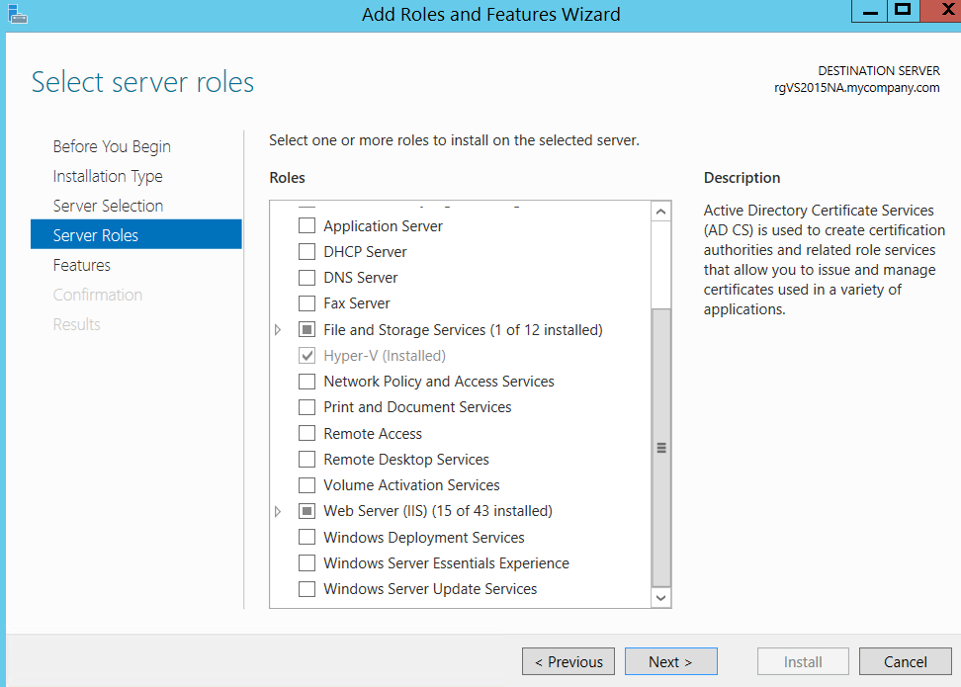

* If this is a fresh machine, installing IIS alone won’t be enough (you’ll face config errors when running). On server 2012 R2, you also need to make sure that you’ve installed “Application Server” role as well as the optional “Web Server (IIS) support” feature under Application server as shown below:

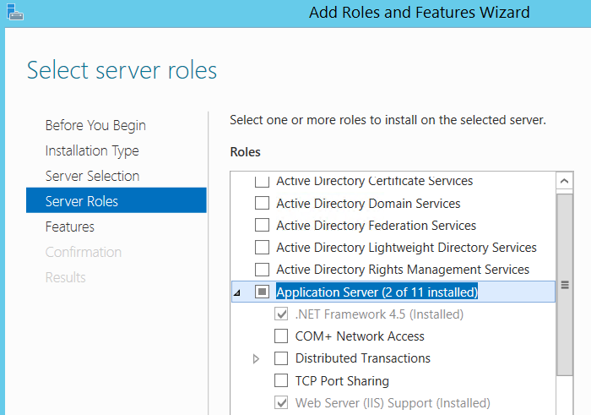

* Also make sure to give permissions to the CloudShop folder to “Everyone” and also make sure that the folder/files are NOT “Read-Only”.
* Extract CloudShop to a local folder.
* Launch VS 2015 in administrative mode and open the Solution file (CloudShopSolution.sln).
* VS 2015 will automatically setup IIS and host CloudSolution to it. You should see something like below.

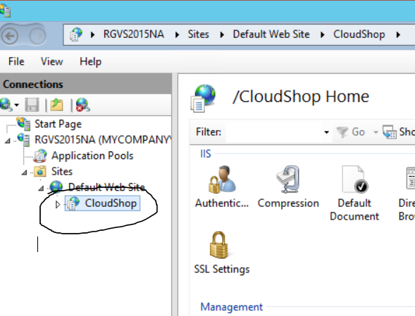

* Run the application from Visual Studio and you should be able to see the app running on localhost as seen below.

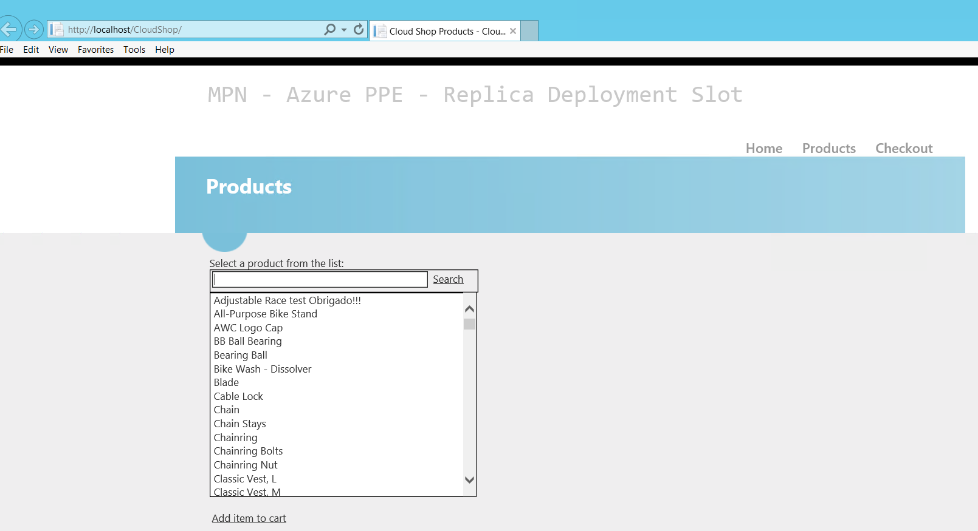

* If you see an ADO.NET error, then that’s probably because the project uses AdventureWorks Databases hosted at sw7heo19qc.database.windows.net and uses connection string mentioned in web.config a sshown below.



If for some reason, this database is unavailable, please host [AdventureWorks](http://msftdbprodsamples.codeplex.com/releases/view/37304) Database in your own publicly accessible SQL Database and replace the connection string.

* Congratulations! CloudShop is now setup to run on an IIS VM.

# Connecting Visual Studio with Azure

Before we could migrate on premise CloudShop to Azure Web Role, we need to connect Visual Studio to Microsoft Azure. Below steps demonstrate how to do so.

* Open “Server Explorer” in VS 2015 as shown below.

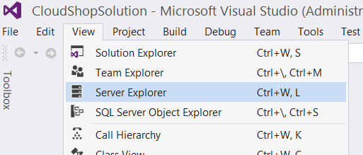

* From Server Explorer, click on icon to connect to Microsoft Azure Subscription as shown below.

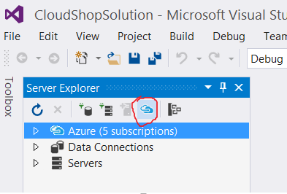

* Follow the wizard and input your credentials for your Azure Subscription.
* Congratulations! Your Visual Studio is now connected to your Azure Subscription.

# Create an Azure VM and enable Web Deploy from Visual Studio

* Right click the CloudShop project and choose “Publish”.
* Select option for “Microsoft Azure Virtual Machine” and choose to create a new VM as shown below.

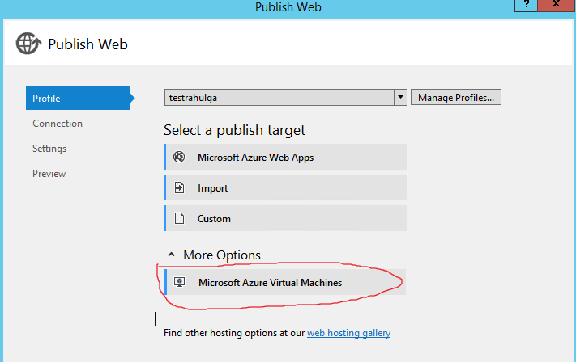

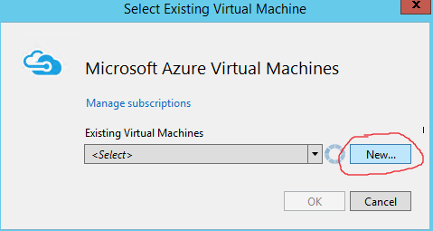

* On subsequent screen fill details of the VM that you want to create. These details include subscription name, name of VM, location etc.. Once you click OK, VS will start provisioning the VM and you will receive confirmation dialog as shown below.

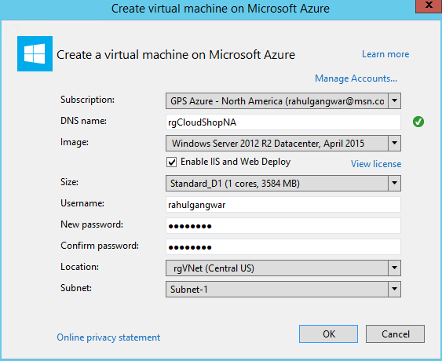

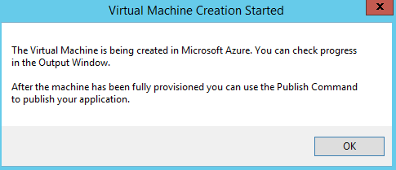

* Please wait till VS has successfully provisioned the VM as well as enabled web deploy. This might take a while. Output logs are shown below.

Web Deploy: <http://weblogs.asp.net/scottgu/automating-deployment-with-microsoft-web-deploy>

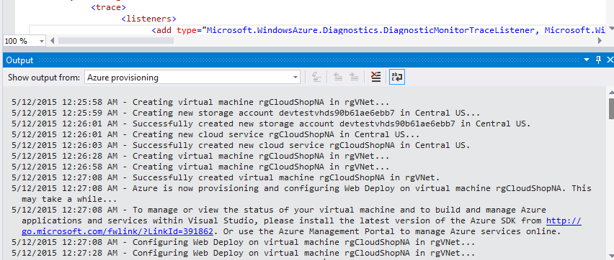

* Once you see the log that asks you to go ahead and publish (as shown below), follow further steps.

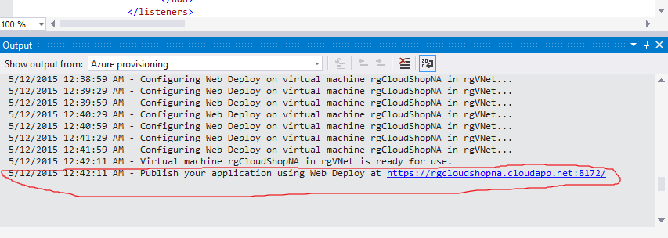

* Congratulations! You have successfully created a VM on Azure and also enabled it for web deploy. You can verify the created VM and its endpoints from portal as shown below.

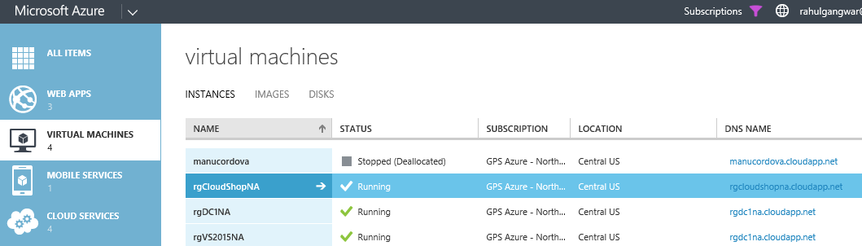

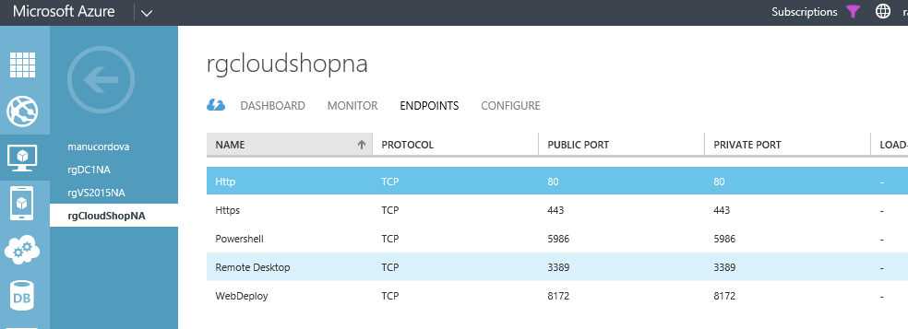

# Publish website to Azure Virtual Machine

* Right click CloudShop project and select “Publish”.
* You will see that the Publish dialog has automatically been pre-filled by VS for the newly created VM as shown below.

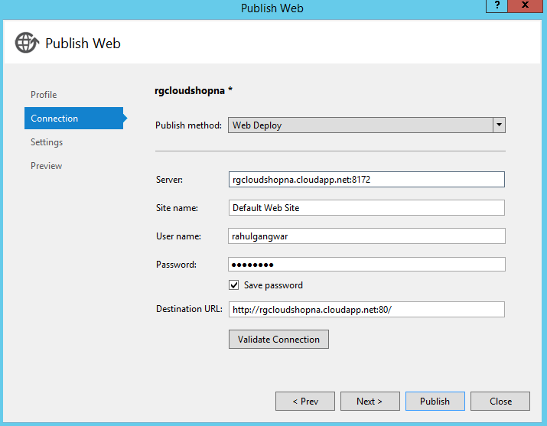

* You can click on “Validate Connection” to see if everything is setup correct. During validation, you will be prompted for certificate warning. Accept and Save the certificate as shown below.

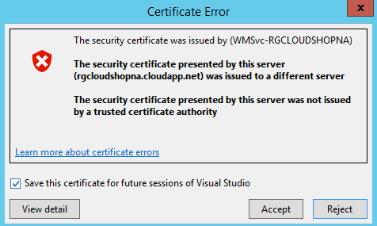

* Finally you will be back to previous screen with connection validated as shown below. Click on Publish button.

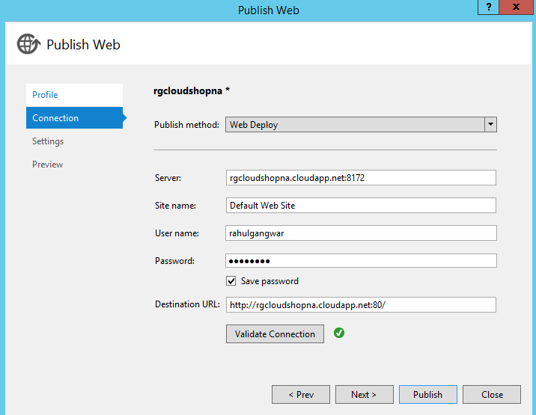

* VS will start publishing your website. Once done you should see an output log similar to below.

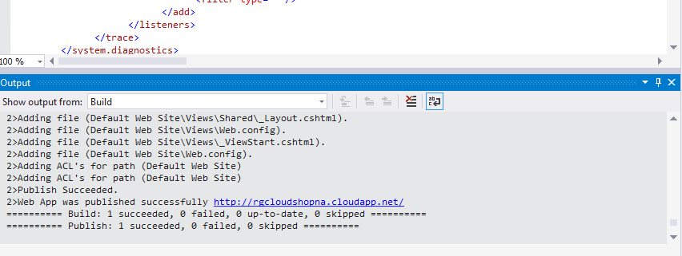

* Congratulations! You have successfully published your IIS website to Azure Virtual Machine. You can now navigate to it publicly as shown below. In fact VS will automatically open the browser pointed to VM hosted website for you.

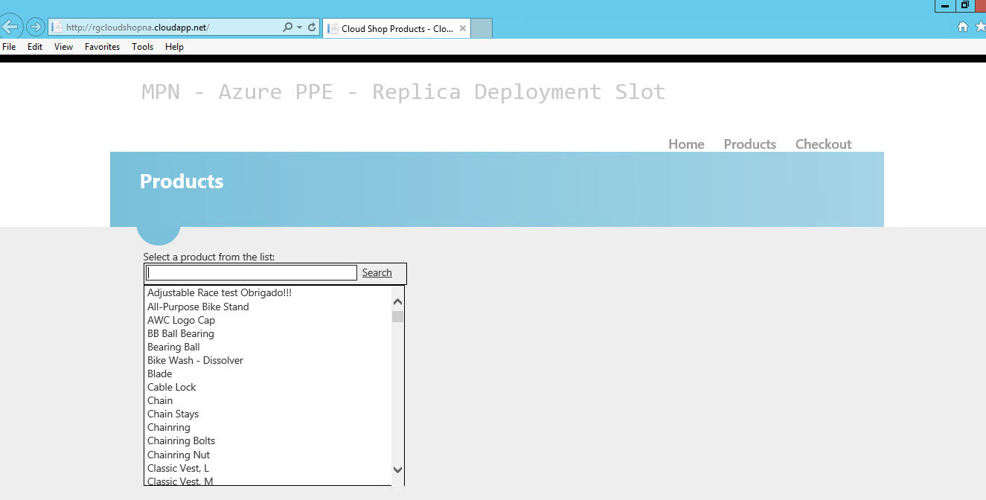

Lab Completed!